Student’s name | …………………………………………………….…… | Grade | 5
Subject | Computer | Quiz No. | 1
Quiz No. ( 1 )
Question A: Fill in the blanks with the words in the box below.

Show different steps or stages involved in a process.

Clouds | Rain | Rivers | Sea | Steam
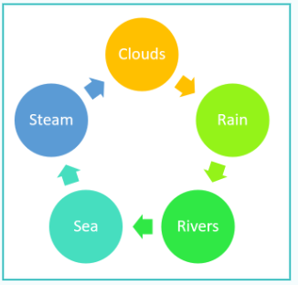
Good Luck
………………
………………
………………
………………
………………….

